ME339 Final Project

Jane Q. Public¹, John I. Doe², and G. I. Joe³
Department of Mechanical Engineering, Stanford University
Stanford, California

Abstract. The abstract should summarize what you did and what you learned quantitatively. Summarize the important results for easy reference. Don’t just write something along the lines of “This paper describes the design of X, outlines the fabrication and testing methods, and analyzes expected performance.” Instead be specific about the main features of the design, results of your analysis, and summarize key features of how you would make and test it. The summary should be substantive but generally should not include figures or references. Your paper should summarize expected device performance quantitatively; describe methods, materials, challenges of your design. Formatting and content descriptions are provided here.

Background. In this section, discuss what you set out to do, your design requirements, and compare and contrast to prior work.
The Annual Poster Sessions for Stanford University’s E240, Introduction to Micro and Nano Electromechanical Systems (M/NEMS), will be held on December 3 and 5, 2008, from 2:15 to 3:45 pm on the steps of the Durand building on Stanford University Campus. Papers for each project should be submitted electronically as PDF files by 5pm Tuesday, December 2. These papers will be printed and bound into “ENGR240 Class Proceedings” and distributed at the poster sessions.
Design. In this section, explain to the teaching team what your design looks like and why. Pictures/cartoons are truly worth a thousand words. The document should have a total length of no more than four pages. The first page should include title, authors, affiliations, and technical description. Figures, tables, and equations may be interleaved with the text. Cite sources for any data used (e.g. Coefficient of friction, µ).
Fabrication. In this section, describe the materials and process steps proposed to make your design and justify your selections for the teaching team. A clearly annotated process cartoon with top and side views and a materials color key will make this section clear and concise.
The conference proceedings will be published on double-sided Letter size paper, 11” high and 8.5” wide. Define 1” margins on top and bottom, and 0.55” left and right margins. Use a two-column layout, with a space of 0.2” between columns. The title/author/affiliation section should be centered above both columns. Once you have completed your paper, adjust the two columns to equal length, as much as possible.
Please use Times New Roman throughout the entire manuscript, from title, authors, affiliation, and headers, to figure and table captions, and references. When using symbols such as √, please use the font of Symbol only. To achieve a unified look across the proceedings, the following formats are preferred for the main paragraph types, as illustrated also by this sample manuscript:
• Title: 12 points, bold, with Small Capitals;
• Authors: 11 points, italic;
• Affiliation: 11 points, regular;
• City, State: 12 points, regular;
• Text body: 10 points, regular; paragraphs without indent
• Figure captions: 10 points, italic;
• Table captions: 10 points, italic;
• References: 10 points, regular, numbered in [ ].

Analysis of Performance. In this section, you should quantify the expected performance of your design and how you will test it. Justify your assumptions and compare expected performance to existing devices. Graphs, tables, figures summarizing these data will convey this information succinctly.
Figures and illustrations should print and reproduce well in black and white or grey-scale. Digital images, e.g., schematic drawings, photos, micrographs, etc., should have resolutions 300 dpi (or greater) with all fonts embedded. We suggest you use a 2-row borderless table to insert a graphic in the top row and the caption below or a text box for your graphic. In MS Word, these methods are more stable than directly inserting a picture. Format tables by selecting “Table Properties” under the “Table” menu. Format text boxes by selecting the text box and then, under the “Format” menu, select “Text Box”.
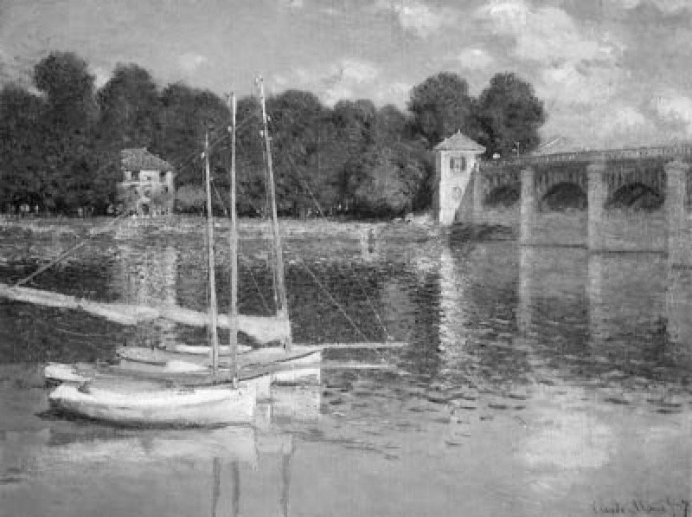
Figure 1: Reflections on corrugated liquid/gas interface, with obstacles, observed by Monet. Rendering with 300 dpi
Each figure should be accompanied by a numbered caption and referenced in the text, as shown in Fig. 1, placed directly below the figure being described. All labels within the figure frame should be in font 9 points or larger. Please ensure that all labels, arrows, lines, and other graphical elements superimposed on schematic drawings and micrographs print with sufficient contrast. Employ descriptive captions that provide interpretation and draw conclusions from the figure or table.
Figure 2. The undeformed structure dimensions …
Figure 3. The actuated beams displaces D under V…
Tables should span one column and should be preceded by a caption. Table 1 illustrates a possible design. Design details are left to the author’s discretion. If a table or figure is too wide to be contained in a single column, extend it over both columns, preferable at the top or bottom of a page.
When numbering equations, enclose numbers in parentheses and place flush with right-hand margin of the column, i.e., with appropriate punctuation. Similar to figures, it is somewhat more stable to insert equations into a 2-column borderless table with the second column used for the equation number. For equation variables, numbers, and physical symbol, indexes etc. follow IEEE usage, cf. the Journal of Microelectromechanical Systems.
When including equations, always define the variables. Such as, the energy consumed, E, can be calculated by
where V is the applied voltage, i is the measured current, and t is the time of operation. A number of words with specific technical meanings (e.g. “power,” “energy” or “efficiency”) also have casual uses in the English language. Make sure when you use these terms in design documentation that you are consistent with the technical definitions.
(1)
Conclusions. So when all is said and done, why should we make this device? What aspects of the design should we be confident will work as expected? Where should we be careful or perform additional testing?
Figure 4. SEM shows the film stack geometry cross section and relation of the electrodes

Figure 5: Magnified SEM of xxxxxxxxx. this is a terrible caption, what do I want you to take away from viewing this?

Table Head | Table Column Head
Table Head | Table Column Subhead | Subhead | Subhead
Copy | More table copy
Table 1. Sample Table Format

Figure 6. Spectral content of diffracted light from a programmed grating for single (upper) and double (lower) band pass filters. Differences between simulated and measured spectra likely arise from…

References. Use IEEE referencing styles as shown in this sample manuscript for contributions to conference proceedings [1], journals [2], and books [3].
[1] S. Senturia, “Perspectives on MEMS Past and Future: the Tortuous Pathway from Bright Ideas to Real Products”, in Digest Tech. Papers Transducers‘03 Conference, Boston, June 8-12, 2003, pp. 10-15.
[2] T. Tsuchiya, O. Tabata, J. Sakata, Y. Taga, “Specimen Size Effect on Tensile Strength of Surface Micromachined Polycrystalline Silicon Thin Films”, J. Microelectromech. Syst., vol. 7, pp. 106-113, 1998.
[3] M. Crichton, Prey, Harper Collins Publishers, Inc., New York, 2002.

